Name: _______________________________________________
Foundation Unit 10 topic test
Date:
Time: 35 minutes
Total marks available: 29
Total marks achieved: ______

Questions
Q1.
Reflect the shaded shape in the mirror line.
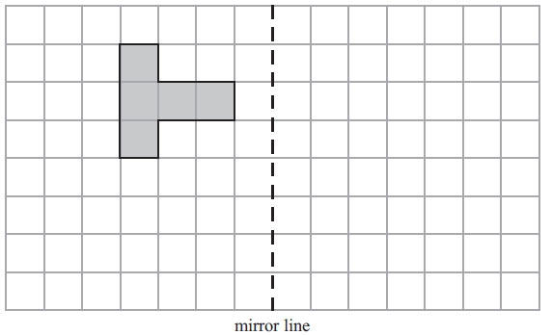

(Total for Question is 2 marks)

Q2.
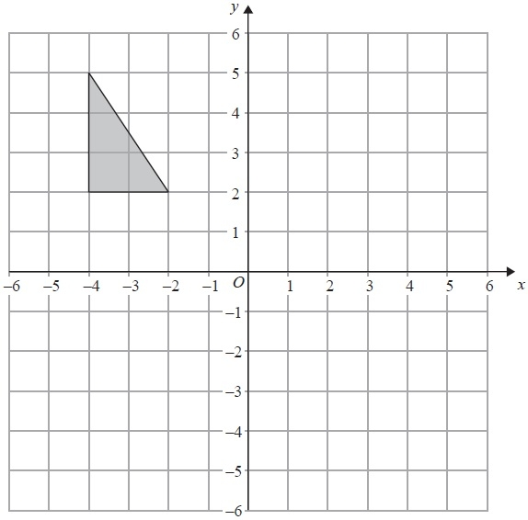
Reflect the shaded triangle in the y-axis.
(Total for Question is 2 marks)

Q3.
Here is a shape drawn on a grid.
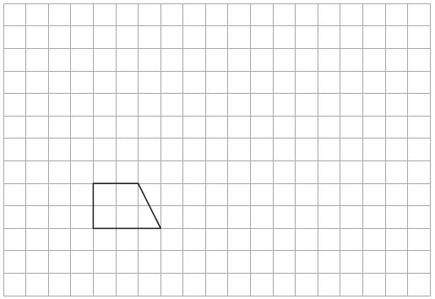
(a) On this grid, draw an enlargement of the shape with scale factor 3
(2)
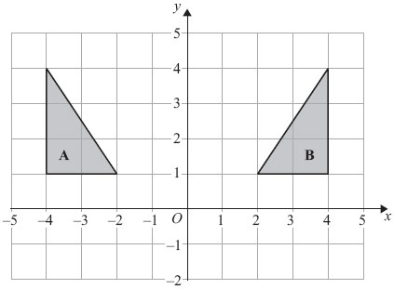
(b) Describe fully the single transformation that maps shape A onto shape B.
..............................................................................................................................................
..............................................................................................................................................
(2)
(Total for Question is 4 marks)

Q4.
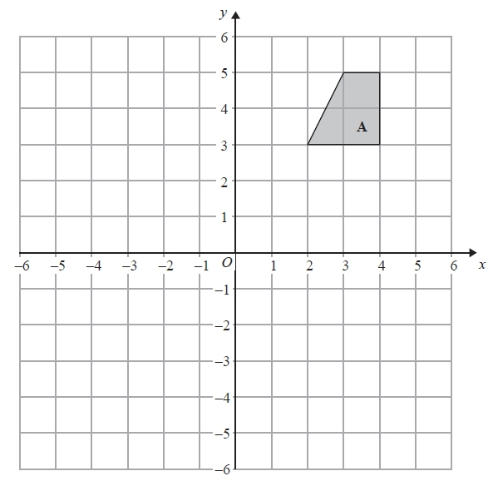
On the grid, rotate shape A 180° about the point (1, 1).
(Total for Question is 2 marks)

Q5.
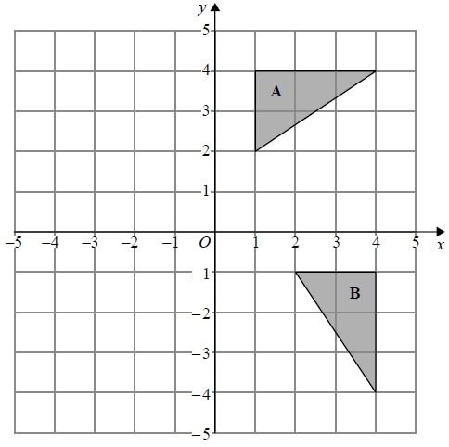
Describe fully the single transformation that maps triangle A onto triangle B.
.............................................................................................................................................
.............................................................................................................................................

(Total for question = 2 marks)

Q6.
Here are two squares.
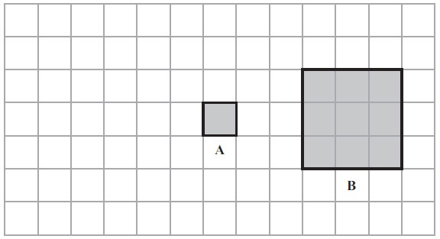
Square B is an enlargement of square A.
(a) What is the scale factor of the enlargement?
..............................................................................................................................................
(1)
Square A is moved 4 squares to the left.
(b) On the grid, draw the new position of square A.
(1)
(c) In the space below, draw accurately a square with side of length 4 cm.

(2)
(Total for Question is 4 marks)

Q7.
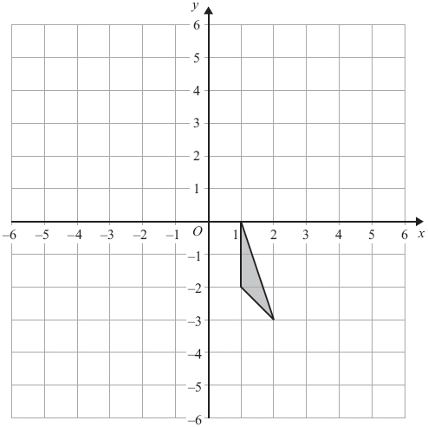
Translate the triangle by 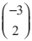.

(Total for Question is 2 marks)

Q8.
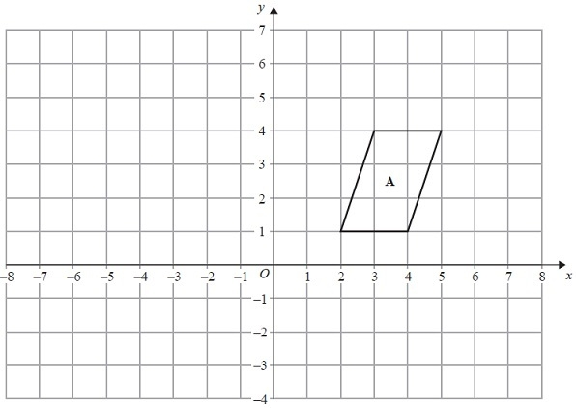
(a) Translate shape A by the vector 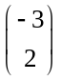.
(1)
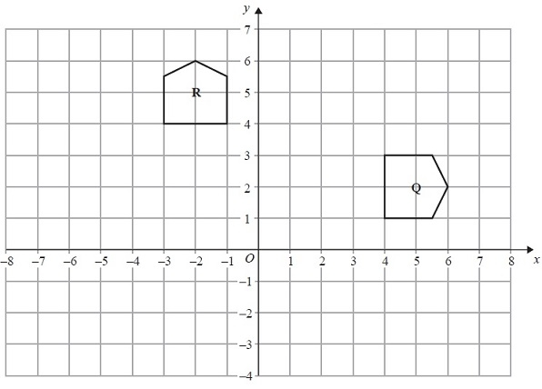
(b) Describe fully the single transformation that maps shape Q onto shape R.
.............................................................................................................................................
.............................................................................................................................................
.............................................................................................................................................
.............................................................................................................................................
(3)
(Total for Question is 4 marks)

Q9.
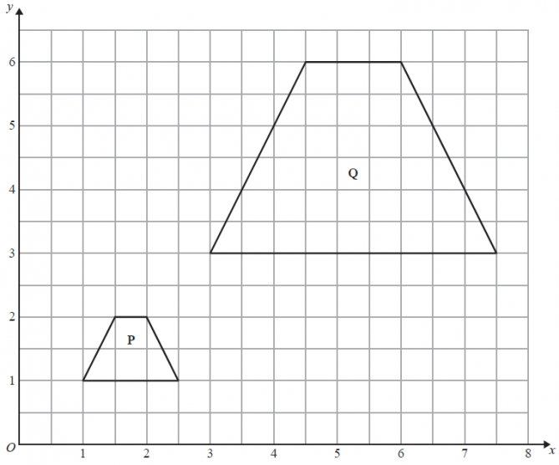
Describe fully the single transformation that maps shape P onto shape Q.
.............................................................................................................................................
.............................................................................................................................................
(Total for Question is 3 marks)

Q10.
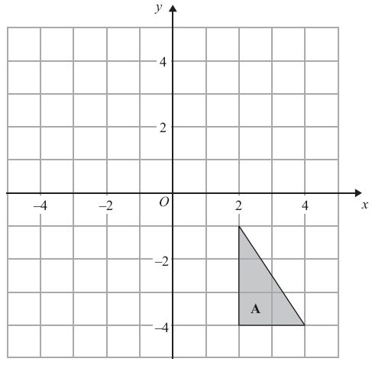
(a) Reflect triangle A in the x-axis.
(2)
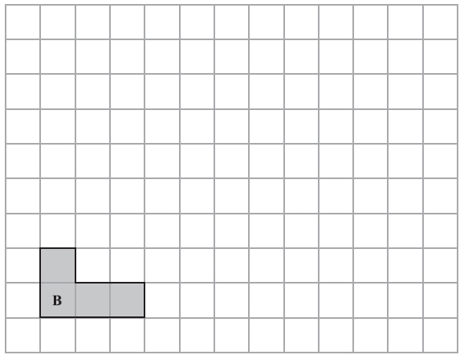
(b) Draw an enlargement, scale factor 3, of shape B.
(2)
(Total for Question is 4 marks)

Examiner's Report
Q1.
Candidates were very successful answering this reflection question with only a few losing a mark for slightly incorrect positioning of the image.

Q2.
As one might expect many candidates made the usual mistake of reflecting in the wrong axis but were awarded one mark, as were those that reflected in a line parallel to the y axis. Some candidates 'hedged their bets' and drew two or three triangles, and therefore gained no marks whilst others drew translations instead of reflections.

Q3.
Few candidates scored all four marks on this transformation geometry question. One was the modal mark awarded in part (a) as candidates often made a mistake with the bottom 9 cm line. In part (b) candidates often lost marks through using non-mathematical terminology. Marks were awarded for derivatives of reflection, e.g. reflected, but not for flipped or mirrored and the correct line had to be stated, i.e. y-axis or x = 0. Many candidates of course made the usual mistake of calling it the line y = 0 or even y = x. Many correctly identified a reflection but then also thought there was a translation involved as well so lost marks as only a single transformation gained any marks.

Q4.
This was an accessible question for many candidates. A good proportion scored 1 mark by rotating the shape through 180° but not always about the correct centre. Many correct answers were seen.
Very few candidates changed the size of the shape but some did draw a reflection.

Q5.
No Examiner's Report available for this question

Q6.
The correct scale factor was given by over a half of all candidates. The two most common incorrect answers seen were 2 and 9. Sometimes answers in an incorrect form were given. For example 1 × 3 and 3 × 3 were seen quite often.
Well over 80% of candidates were able to move the square 4 squares to the left. Small number of candidates either moved A one too many squares to the left or drew a 3 by 3 square. In order to avoid the former error candidates could be advised to concentrate on one corner at a time rather than the whole shape.
In part (c) squares were usually drawn accurately and within the tolerances allowed by examiners. Almost 90% of candidates scored full marks for their drawing with a further 7% of candidates scoring 1 mark for either a side of correct length or a 90° angle. A few candidates drew rectangles rather than squares.

Q7.
The majority of candidates knew what was meant by the term "translation" and nearly 1 in 6 candidates could be awarded a mark for translating the triangle albeit often by the wrong vector. Twenty two per cent of candidates gave a fully correct answer. There was no single common error though errors usually involved an incorrect interpretation of one or more of the components of the vector. Very few candidates tried to rotate, reflect or enlarge the triangle and in most cases their transformed shape was congruent to the original shape.

Q8.
Errors in part (a) involved transposing the x and y parts of the vector or moving the shape to a position where one vertex was at (−3, 2). Others used the vector incorrectly to move the top right (5,3) vertex to (0, 6), the position that top left (3,4) vertex should have after translation.
Incorrect mathematical language and lack of detail spoiled many descriptions in part (b) with "turn" often given instead of rotation and errors or omissions with the direction or centre. Students need to be clear about which of the 2 diagrams is being rotated to prevent errors with direction. All marks were lost when a candidate introduced a second transformation, usually a translation.

Q9.
Over one third of students recognised the transformation as an enlargment and gave the correct scale factor but correct identification of the centre of enlargement was very rare indeed. Many students lost marks through giving multiple transformations as answers, mostly in an attempt to give information about the position of the image in the absence of a centre of enlargment. Typically, a translation was described or vector given.

Q10.
Both parts of this were standard transformation tasks. There was some confusion in the minds of many candidates as to which was the x-axis - many gained 1 mark by carrying out a reflection in the y-axis. Although most candidates drew a reflection there were a few rotations and even translations.
Whilst many candidates scored 2 marks on part (b) there were a lot who did not understand the idea of enlargement and simply extended a couple of sides, usually the bottom and left hand. A few candidates carried out an enlargement with scale factor 2

Mark Scheme
Q1.
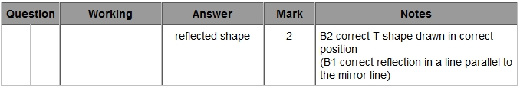

Q2.
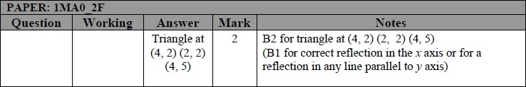

Q3.
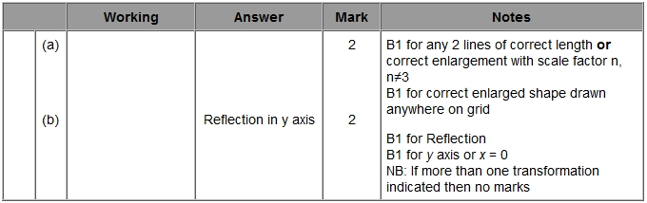

Q4.
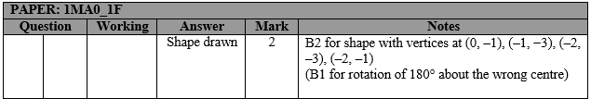

Q5.
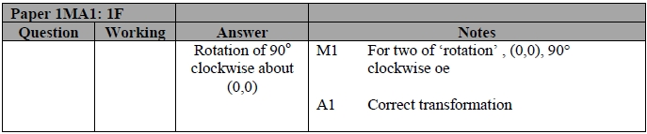

Q6.
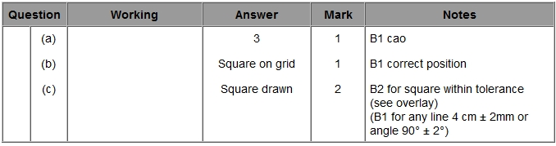

Q7.
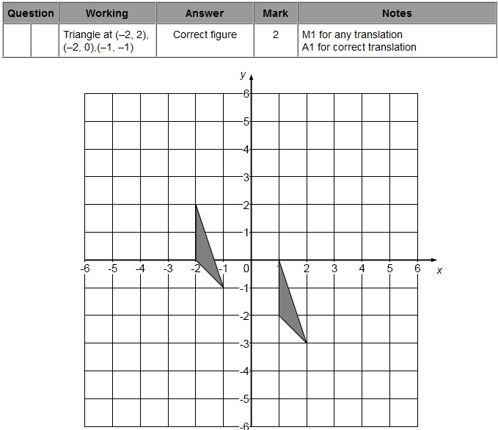

Q8.
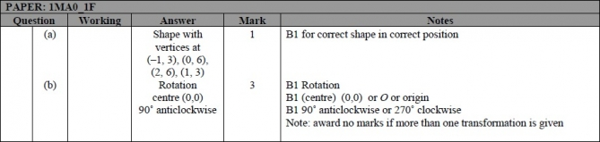

Q9.
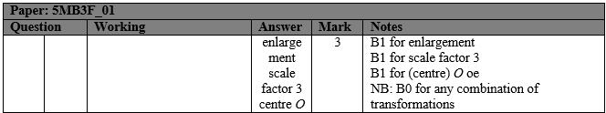

Q10.

